BFS

The backbone of a breadth-first graph traversal consists of these basic steps:

algorithm :

|  |  |
| --- | --- |
| BFS(startNode){ |  |
|  | var visited = {}; |
|  | var Queue = []; |
|  | visited[startNode] = true; |
|  | Queue.push(startNode); |
|  |  |
|  | while(Queue.length > 0) |
|  | { |
|  | var getElement = Queue.shift(); |
|  | document.write(getElement); |
|  |  |
|  | var get_list = this.adjList.get(getElement); |
|  |  |
|  | for(let i in get_list){ |
|  | var neigh = get_list[i]; |
|  | if(!visited[neigh]){ |
|  | visited[neigh] = true; |
|  | Queue.push(neigh); |
|  | } |
|  | } |
|  | } |
|  | } |

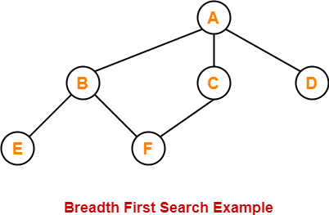

The breadth first search traversal order of the above graph is-

A, B, C, D, E, F